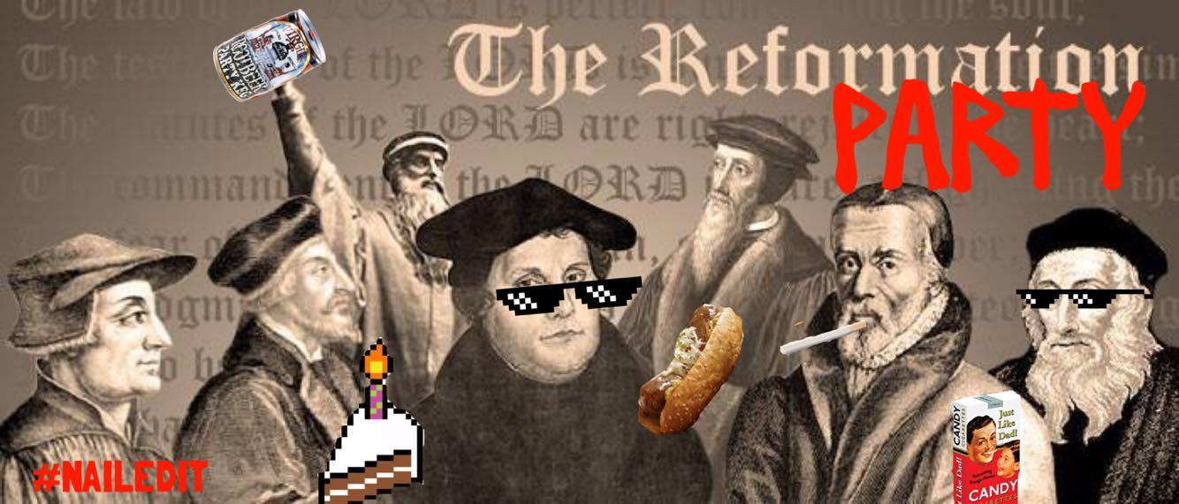
Center U.P. Church
Sat., October 28, 2017
4:00 – 6:30 PM
110 Washington Ave. Midway, PA 15060

This October will mark the 500th anniversary of the Reformation of the Church in Europe. The traditional start of that movement is commonly regarded as Martin Luther's nailing of his 95 theses on the Castle Church door in Wittenburg on October 31, 1517. We want to celebrate our heritage, and acknowledge the effect that the movement had on our faith traditions for centuries to come.

Center, Midway is hosting a
Reformation Dinner on Saturday October 28th 4:00-6:30 PM

- Brats
- Sauerkraut (bring your own and we’ll make it a sauerkraut contest!)
- Black Forest Cake
- Root Beer and more

We are considering the idea of encouraging costumes close to the time period : monk habits, French berets, think Renaissance Fair. More details will come, but for now -

1) As part of the fun, we will have a "Trivia contest" where some of our pastors will compete with questions about the Reformation. Meanwhile, the rest of the group will have "Reformation Lingo Bingo" cards with words in the squares like "justification," "faith alone," "sola scriptura," etc. and they can mark their cards when they hear the terms in the questions or answers.
2) As a further reason to attend, the event will have a secondary purpose as a fundraiser (Cost of tickets $5), with the profits split three ways between:

*McDonald Ministerial Association
*Meals on Wheels
*McDonald Food Bank

MARK YOUR CALENDAR NOW - more information will be forthcoming.
Rev. Brian Kilbert – 724-678-6976.

