Keynote Speaker: David Hansen

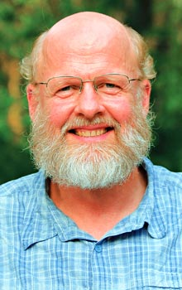

David Hansen is the recently retired Pastor of Heritage Community Church in Cincinnati, Ohio. He also pastored in Montana, the setting for many of the stories in his book *The Art of Pastoring: Ministry Without All the Answers* (IVP). Hansen is also author of *Loving the Church You Lead: Pastoring with Acceptance and Grace* (Baker) and other books. He has been a contributing editor for *Leadership Journal*, and is a frequent speaker at pastoral ministry conferences.

The Presbytery of Lake Erie invites you to a day filled with learning and worship. You will leave feeling encouraged, refreshed, and readied for joyful service to our Lord. The price for the day is only $15.

Schedule:

9:00-9:35 Registration

9:35-9:50 Opening Worship

9:50--10:50 Keynote Address

10:50-11:00 Transition Time

11:00-Noon First Workshop

Noon-1:00 Lunch

1:00-2:00 Second Workshop

2:00-2:10 Transition Time

2:10-3:00 Keynote Address and Worship

Pick Your First Workshop “A”

**A1 Stewardship and the Generations**: This workshop will explore the work of the Rev. Dr. Karl Travis on generational theory and stewardship.  From formative experiences of money, common experiences of stewardship, understanding of money, financial realities, motivators of generosity, and trust of the institution, workshop participants will depart with ideas on how to effectively communicate with the various generations to encourage generosity across the board.  Presenter - Rev. Ellie Johns-Kelley, a member of the Presbytery of Lake Erie as well as Ministry Relations Officer for the Presbyterian Foundation serving the Northeast.

**A2 Pastor’s Roundtable with David Hansen:** Come and find solid advice and encouragement for your ministry from a joyful veteran pastor. Discuss the art of “successful” pastoral ministry and leadership without needing to have all the answers.

**A3 Developing and Sustaining Music Ministry:** What are some practices and strategies for successfully engaging people in music ministry, even when they don’t think they have the gifts and ability to help? Presenters – Jane Livingston, Director of Music, North East, and Rev. Emily Zeig Lindsey, Waterford Church.

**A4 "Reaching Across the Rivers"- 3 Churches in Oil City:** The Oil City Presbyterian congregations are working to be the hands and feet (eyes-ears-voice) of Christ on the ground in the Oil City area. The 3 churches in Oil City are unique in gifts and services. We share the desire to "live out" the call to serve Christ in new ways in our community. Our ministry/services are reaching out to our community in new (and sometimes) challenging ways. Our goal for this workshop is to encourage others to find ways to become "missional" in your communities and to learn ways in which your congregations are living this out. Presenter – Rev. Ronee Christy, Oil City, First, and Friends.

**A5 Stephen Ministry: Caring for Your Congregation**

All too often deacons and elders find themselves wanting to offer care and help to members of their congregations but without knowing what to say or do. Stephen Ministry is a lay-caring ministry being used by thousands of congregations to increase care and outreach to hurting people. Imagine this quality ministry of presence happening regularly and consistently in your congregation. Presenter – June Kessler, Saint Paul’s Lutheran Church.

Pick your Second Workshop “B”

**B1 "What is God Up to in Your Neighborhood?"**

Find out how the North Warren Presbyterian Church sought to answer that question as they explored the changing face of their community.  For over 7 years NWPC has partnered with their neighbors as they engaged the children, parents, and families in their area through their Community Day Camp.  Buddy Ward will present not only what this congregation does to implement this annual outreach, but also how they prepare, adapt, and evaluate, what has become a highly anticipated event.  He will also explain how "Missional" thinking has transformed the way the North Warren Church views their ministry in our post-modern culture. Presenter – Rev. Buddy Ward, North Warren.

**B2 Refreshing Your Prayer Life: Learning to Pray the Psalms:** Ever get frustrated in prayer; perhaps even bored? Has prayer become a mechanical routine or does it seem like an obligation? Do you find yourself praying about the same five or six things or in the same ways? Come and learn a simple, life-giving way to pray based on an ancient form of prayer. Presenter – Rev. Gregg Townsend, North East.

**B3 Commissioned Pastor Ministry:** Commissioned Pastor ministry is a growing presence in the Presbytery of Lake Erie. What is a Commissioned Pastor? What is their preparation process and academic training? What is the difference between a CP and an ordained Minister of Word and Sacrament? What is it like serving as a CP in our Presbytery? Presenter – Patti Orton Kuna, Commissioned Pastor, Sugar Grove.

**B4 Pastor’s Roundtable with David Hansen:** Come and find solid advice and encouragement for your ministry from a joyful veteran pastor. Discuss the art of “successful” pastoral ministry and leadership without needing to have all the answers.

**B5 Ghana Mission Partnership:** There are exciting developments in the growing partnership between the Upper Northern Presbytery in Ghana and Lake Erie Presbytery!  Come and learn how God is at work and how you and your church can participate (and learn!!) even if you never travel to Ghana yourself.  Ghana is a hospitable culture from which we can learn a great deal.  A great opportunity to enhance your church’s understanding of God’s work around the globe.  Presenters: Donna Cammarata, Fairview and Bill Tauber, First Presbyterian Church of the Covenant.

**Registration Form:**

Name __________________________________

Address ________________________________

Phone _________________________________

Email address ___________________________

Church _________________________________

Workshop Choices:

Workshop A _________2nd choice___________

Workshop B _________2nd choice___________

**Babysitting:**Do you need babysitting? ______

Please provide ages ______________________

Special needs for child care ________________

**Parents are responsible for their children during the lunch hour.** Parents can bring a meal for their children or purchase an adult meal for them.

**Menu:**The noon meal will be provided by the host church, First Presbyterian Church of the Covenant. Please call the presbytery office – 814-868-4891, Ext. 3 – if you have special dietary needs or with any questions.

**Cost:**Cost is $15, payable online, in advance by mail, or at the door. Cost includes the noon meal as well as participation in all the day’s events. Please register online at www.pbylakeerie.org or return this form via the mail by February 28, 2018.

Presbytery of Lake Erie  
2816 Elmwood Avenue  
Erie, PA 16508

**Directions**

**First Presbyterian Church of the Covenant**

250 West 7th Street, Erie, PA

814-456-4243

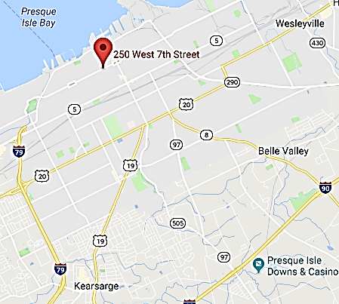

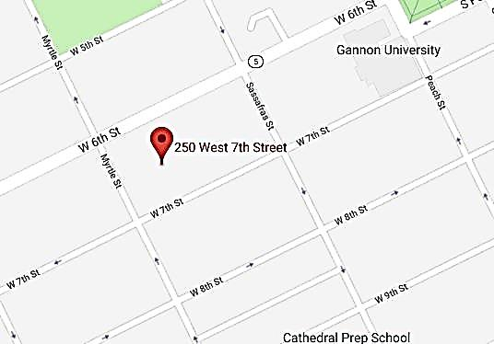

The Big Event:

Discovering Joy Right Where You Are





March 10, 2018

First Presbyterian Church of the Covenant

250 West Seventh Street, Erie, PA 16501

9:00 AM to 3:00 PM