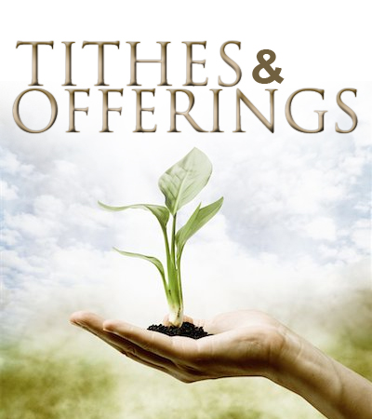

“Each of you must give as you have made up your mind, not reluctantly or under compulsion,   
**for God loves a cheerful giver.”**  
*2 Corinthians 9:7*

**Insert your**

**church’s logo here**

Church website address

Church website address



Electronic giving services powered by



*Please feel free to place this card in the offering plate to signify your financial support of the mission of the church.*

**Ways to support CHUCH NAME HERE**

1. Place cash or check in the offering plate.

2. Use your bank’s online bill pay to send a payment to the church.

3. Setup an Electronic Funds Transfer from your savings or checking account on our website or scan the QR code below.

4. Use your debit/credit card on our  
website or scan the QR code below.

5. Make a gift of stock or other appreciated securities. Contact the church office for more information.

6. Remember the church in your will and your estate plans. Contact the pastor for more information.