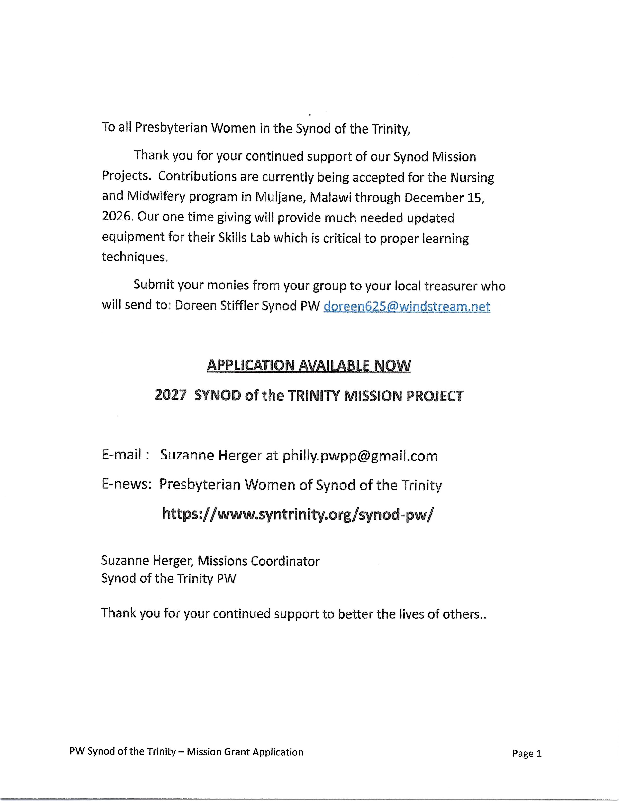

PRESBYTERIAN WOMEN - SYNOD OF THE TRINITY
Mission Project Grant Application
2027
(Application must be typed)

Organization Name:___________________________________________________

Project Name:_________________________________________________________

Project Address: _______________________________________________________

Website: _____________________________________________________________

Presbyterian Women Contact: _________________________

Title or Position________________________________________________________________

Presbytery:________________________________________________

Phone: ________________________

Email: _______________________________

Start-up Date for Project: __________________________________________

Questions to be Answered
- Provide a mission statement from your organization and a purpose statement that directly relates to the proposed project. (A mission statement is defined as a cross between a slogan and an executive summary. It should say who your organization is, what you do, what you stand for and why you do it)

- Briefly list the activities of your request and how it will meet basic human needs. (Please limit to 150 words)

- This is a creative project less than three years old _____This is an existing project moving in a new direction _____

- Briefly explain how a one-time grant will help this project and assist the persons served. Describe how this will impact the lives of women, children, youth and young adults, racial-ethnic persons or persons with a disability.

- What expected changes, either long-term or short-term, would receiving this funding allow?

- Specifically how would funds received from Presbyterian Women in the Synod of the Trinity be used?

- How will the program continue once the received funds are depleted?

- List other sources of funding being sought for this project:

Funding Source Amount Requested Assured to Date Date Decision Expect

_____________ _______________ _____________ _________________

_____________ _______________ _____________ _________________

______________ _______________ _____________ _________________
- Describe your process of evaluation and accountability.

- Identify dates of previous funding request(s) to Presbyterian Women and outcome.

Date Amount of Grant Name of Project Birthday or Thank Offering, etc.

_____ _____________ ________________ ______________________

_____ _____________ ________________ ______________________

- Attach a project budget, in US currency, that shows specifically how the money will be spent.

- Attach any available pictures (preferably black & white) of the current circumstances or structures and pictures or drawings of the proposed project.

---------------------------------------------------------------------------------------------------------------------
Name of person submitting application
_______________________________ _______________________________________
Address ________________________ _______________________________________
_______________________________
_______________________________
Telephone (___)__________________
Email___________________________

_______________________________

Signature (required)

Date_________________
Relationship to Project________________

Name of Board chair or other responsible person _______________________________
Address ____________________________________
Synod _______________________________
_______________________________
Telephone (___)_____________________
Email___________________________

_______________________________
Signature (required)
Date_________________
Relationship to Project________________

